
WELSH LANGUAGE COURSES 2026-2027
Please choose a course which is convenient for work / life balance.
1. RCT COUNCIL COURSES
2. LEARN WELSH
3. ONLINE LEARNING APPS/RESOURCES
CYMRAEG GWAITH
SAY SOMETHING IN WELSH
DUOLINGO
4. CONTACT DETAILS

1. FREE RCT COUNCIL COURSES – These course are provided by RCT Council’s Welsh Language Tutor

Level | Location | Day | Time | Length | Cost | Start Date
Welsh Language Skills Level 1 | Online learning self-study course – available to download on RCT Source or use this link CwrsCymraegLefel1 | NA | NA | 2 hours | Free | NA
Bitesize Work Welsh | Virtual classroom on Teams – go to RCT Source to book a place | TBC | TBC | 2 hours | Free | TBC
Entry 1 (beginners) | Virtual Classroom on Teams | Monday | 10:00-12:00 | 32 weeks | Free | 09-2026
Entry 1 (beginners) | Virtual Classroom on Teams | Thursday | 13:00-15:00 | 32 weeks | Free | 09-2026
Entry 2 | Virtual Classroom on Teams | Thursday | 09:30-11:30 | 32 weeks | Free | 09-2026
Foundation 1 | Virtual Classroom on Teams | Wednesday | 13:00-15:00 | 32 weeks | Free | 09-2026
Foundation 2 | Virtual Classroom on Teams | Wednesday | 10:00-12:00 | 32 weeks | Free | 09-2026

For further information or to booking a place, email - WelshLanguageOfficer@rctcbc.gov.uk (RCT Council, Welsh Language Services).

You are required to discuss with your line manager before booking on a course. Managers should be aware that increasing the Welsh language abilities of staff will help ensure that the Council meets its Welsh Language Standards requirements. If possible, internal meetings should not be arranged to clash with these courses.

2. LEARN WELSH COURSES
Learn Welsh courses are available during the daytime and evening, face-to-face or in virtual classrooms. You can also study independently, online. Courses are delivered by a network of providers on behalf of the National Centre for Learning Welsh. Courses are available at different learning levels. You can find a course on our find a course or what about starting with one of our on-line taster courses. You can also enjoy our Learn Welsh videos on YouTube.

People aged between 18-25 can have the course for FREE! Discount will automatically be applied when you enrol – no code required.
For further information, to discuss booking a place or to search for additional community provision, contact –

learnwelsh@southwales.ac.uk | Website: Learn Welsh Glamorgan
Facebook: /WelshForAdultsGlamorgan | Twitter: @learncymraegMG



3. ONLINE LEARNING APPS/RESOURCES - Work Welsh
Online Work Welsh taster courses are available at different levels for free. There are courses which are tailored for different sectors, for example Health and Care. Most courses include 10 units each (about 10 hours of learning). Courses start after registration is complete.
Register online here: www.learnwelsh.cymru/workwelshtastercourse
Select Rhondda Cynon Taf County Borough Council as your employer during the registration process.
For further information email office@learnwelsh.cymru or welshlanguageofficer@rctcbc.gov.uk
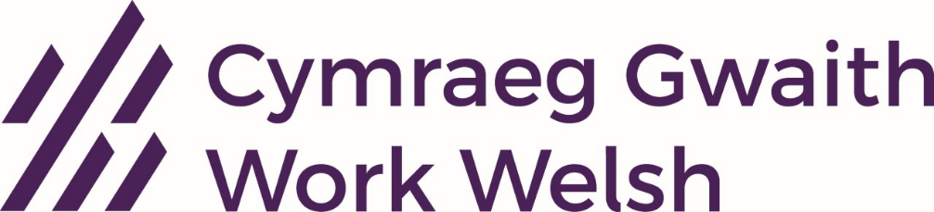

3. ONLINE LEARNING APPS/RESOURCES - Say Something in Welsh
Say Something in Welsh is a Welsh speaking course for beginners to higher level. Lessons are accessed via the “Say Something in Welsh” website or app. Each learning ‘challenge’ lasts about 30 minutes with about 5 min weekly practice sessions. Digital Face to face practice sessions with other learners and tutors are also available at various times during each week. You can still access the old course for free. The new course costs around £10 per month for an active subscription. Courses begin after the simple registration process has been completed.
For further information, please email admin@saysomethinginwelsh.com
Or visit SaySomethingin (old course) / AutoMagic from SaySomethingin Welsh (new course)
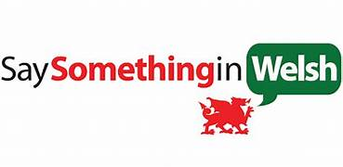

Corporate packages are also available for employers wishing to buy course places for groups of staff.

3. ONLINE LEARNING APPS/RESOURCES - Duolingo

Duolingo is an online Welsh course for beginners to intermediate level. You can access the course via the website or through the Duolingo ap. There is support and occasional online lessons available for free via the Facebook Dysgu Cymraeg Duolingo group. It’s possible to register on the course and access it for free. It costs about £4.99 per month for a subscription which enables you to use the ap ad free and with unlimited hearts. The course will begin after the simple registration process is complete.
For further information, visit the website www.duolingo.com/Learn-Welsh-Online or download the ‘Duolingo App’ in the Android or Apple App Store. Corporate subscriptions are also available.

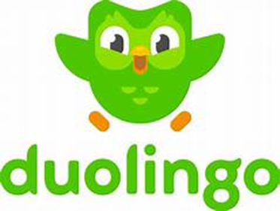

4. CONTACT DETAILS
Welsh Language Services, Rhondda Cynon Taf Council
welshlanguageofficer@rctcbc.gov.uk

Learn Welsh Glamorgan
learnwelsh@southwales.ac.uk

Work Welsh Online Courses
cymraeggwaith@dysgucymraeg.cymru

Say Something in Welsh
iestyn@saysomethinginwelsh.com
Duolingo
www.duolingo.com/enroll/cy/en/Learn-Welsh

