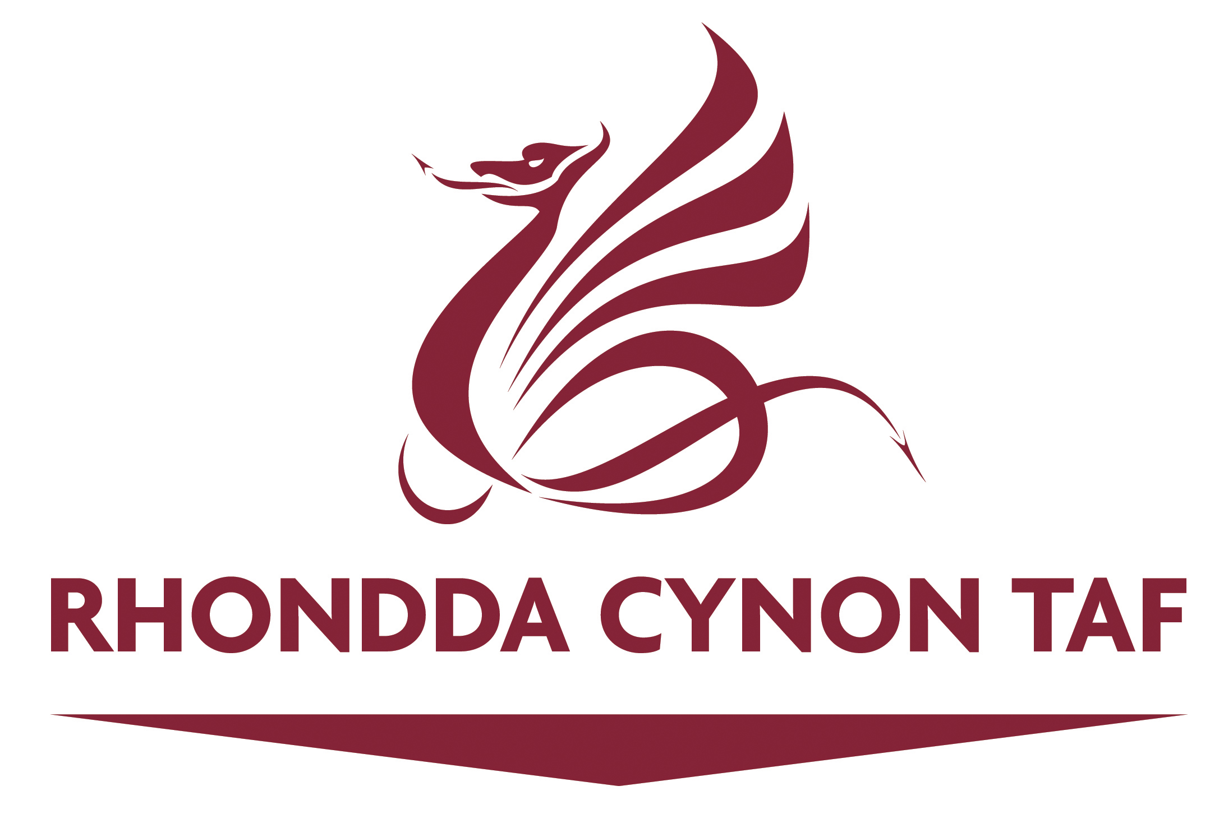

Reference Number |  | Date Received
Name of Organisation |  | Name of Asset or Service

RCT TOGETHER
COMMUNITY ASSET AND SERVICE TRANSFERS

EXPRESSION OF INTEREST FORM
If you would like to discuss your proposals before completing this Expression of Interest Form, please contact the RCT Together Community Asset Development Team on 01443 425368

When completed, please return this form to:
RCT Together
Community Development Team
at
RCT County Borough Council, Community Services, Ty Elai, Williamstown, Tonypandy, RCT, CF40 1NY

DUE TO STAFF CURRENTLY WORKING FROM HOME, PLEASE DO NOT POST THE FORM TO THE COUNCIL OFFICE BUT EMAIL INSTEAD
Please email a copy of this Expression of Interest to the Community Development Team at RCTTogether@rctcbc.gov.uk

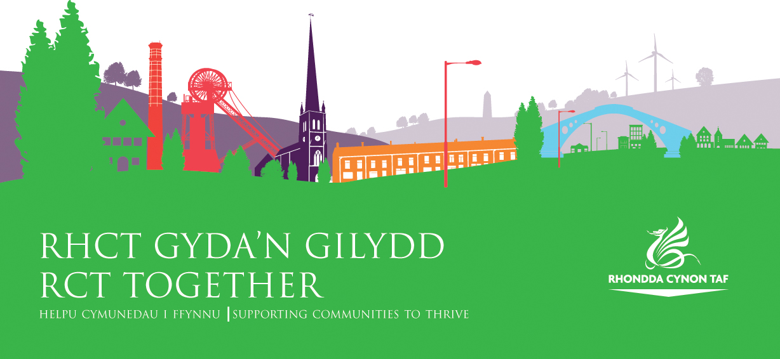
Guidance for completion of the "Expression of Interest" form

The "Expression of Interest" form is an important document, as it gives your organisation/group the chance to share an idea for delivering a service or managing community assets (buildings and land) in the community. We want to know why the service your organisation/group would like to run is important within your local community and/or across RCT.

This information within it will help the Council to identify good community based proposals for sustainable uses of public buildings, land or delivery of services currently owned and managed by Rhondda Cynon Taf Council. The Council will use this information to consider transferring the management of the building or service to your organisation/group ie. a Community Asset Transfer (or CAT).

The aims of a Community Asset Transfer from Rhondda Cynon Taf Council are:

- To encourage local communities and groups (new or existing) to become empowered and active citizens by delivering services and managing local buildings in their local area.
- To develop capacity in communities and promote shared use of community buildings through a collaborative approach between public, private, voluntary and community sectors.
- To safeguard buildings and services for community use and benefit.

When initially assessing your completed "Expression of Interest", the Council will consider:

- Does your proposal demonstrate any potential efficiency savings or added value to managing council buildings and/or services?
- Does your proposal benefit the people of Rhondda Cynon Taf?
- Does your proposal contribute to the Council's priorities and plan?
- Does your proposal address needs identified by your local Community and/or Neighbourhood Networks?

(Follow the link to view the Councils current RCT Corporate Plan “Working With Our Communities” 2024-2030 "Working With Our Communities" 2024 -2030
If your "Expression of Interest" can demonstrate it has the potential to address both the Councils and local communities unmet and/or emerging needs, you will be invited to submit a full, costed Business Plan, which will then be considered for submission as a Community Asset and/or Service Transfer application. If the Council feels the proposal cannot progress, we will write to you and inform you of the reasons why.

If you also want to apply to the Community Asset Transfer Fund to support a successful Community Asset Transfer, then a separate Application Form will be sent out to you for completion.

NB. Important - please read. Where Council assets/services are identified as suitable for Community Asset Transfer, they will be publicised via the Councils website as part of a "Window of Opportunity" to allow other organisations to comment and share their proposals to promote fairness, transparency and strengthen collaborative approaches in the process. RCT Together web link

We will be encouraging groups to work together to maximise use of public buildings and services to ensure long term sustainability of buildings, land and services. There may be opportunities to strengthen individual proposals through this process. As such information you submit in Section 6a may be made available for other organisations to view as part of the Councils "Window of Opportunity".

Please tick if you object to this information being shared to any third parties
Please note that this is an Expression of Interest only and completion of the form does not constitute a guarantee of transfer/lease of an asset, service transfer or award from the Community Asset Transfer Fund.

PROPOSED PROJECT NAME
1. CONTACT DETAILS
Please provide details of the person to whom all correspondence should be sent.
Title (Mr, Mrs, Ms, etc) | First Name: |  | Surname:
Role within the organisation:
Address & Postcode:
Tel:
Mobile:
Email:

2. ORGANISATION/GROUP DETAILS
Please provide details of the organisation making this application.
Name of Organisation/Group:
Address & Postcode (if different from above):

Tel (if different from above):
Fax:
Email (if different from above):
Website:
Facebook Page:
Twitter:
Are you a new or existing organisation/group? | - New (please skip to Section 5)  - Existing
What year did your organisation start?

3. ORGANISATION/GROUP STATUS
Community/Voluntary Group Registered Charity Social Enterprise
Company Limited by Guarantee Town/Community Council Consortium Statutory/Public Body Commercial Business Other (please state)

4. ORGANISATIONAL HEALTH CHECK
Consider your organisation’s ability to maintain service delivery and deliver benefits to local communities.

What are your governance arrangements?
Do you publish an annual report? If yes, please provide the most recent copy.
Do you have a written constitution or governing document eg. Memorandum and Articles of Association. Please provide a company and/or charity registration number (if applicable
Do you have an Organisation/Group – Bank or Building Society Account? | Yes _______ No _________
What financial package is in place to support your proposal and how secure is the funding/income streams?

5. TELL US ABOUT YOUR ORGANISATION (OR GROUP)
- What does your organisation/group currently do? (If you are a new group, skip to Section 5)

- Please provide details of past achievements or recent projects you have been involved in?

6. TELL US ABOUT YOUR PROPOSAL/COMMUNITY IDEA
a) Describe what your organisation/group wants to do?

- Describe how your proposal will meet the identified needs of the community and what evidence do you have to support this?

- Have you discussed your idea with your local Community or Neighbourhood Networks ie other community groups and partners in your community? If so please list the organisations you have discussed your proposal with.

- How do you aim to ensure your proposal is sustainable?

- Council Buildings/Land –
  - Please provide the name of the building(s), address and postcode if your proposal involves taking over the management of a building.
  - If your proposal is for land, please provide an address, postcode or aerial photo outlining the exact boundaries of the land parcel you are interested in.
  - Please advise on the length/duration of the tenancy you require.

- Council Service(s) – If your proposal involves transferring responsibility of an existing Council Service to your group, please list the specific service(s). Please state if you are looking for a whole service transfer i.e. across the whole of RCT, or just in a specific geographical location.

7. BENEFITS
Provide details of the benefits that you consider achievable. You should include benefits to your organisation, to the community and where applicable to RCT.
a) Will the asset enable service improvements? If so, how?
b) Will additional services be provided? If so, what?
c) Will the service become more visible? If so, how?
d) Will the service become more accessible? If so, how?
e) Will the asset complement other services or organisations or enable collaborative working? If so, how?
f) Will it safeguard services? If so, how?
g) Will there be any financial savings? If so, how?

Please tick which objectives of the Rhondda Cynon Taf Corporate Plan your project will address.

PEOPLE AND COMMUNITIES – Supporting and empowering RCT residents and communities to live safe, healthy and fulfilling lives;

WORK AND BUSINESS – Helping to strengthen and grow RCT’s economy;

NATURE & ENVIRONMENT – A green and clean RCT that improves and protects RCT’s environment and nature;

CULTURE, HERITAGE AND WELSH LANGUAGE – Recognising and celebrating RCT’s past, present and future.
Please explain how your project will positively benefit/impact the community?
(This should link back to the objectives you have identified above.)

Does your project positively contribute to RCT Climate Change priorities? If so, how? See link to Think Climate RCT - Making RCT Carbon Neutral by 2030
Will there be Welsh Language opportunities within your project? If so, how?

8. ORGANISATION/GROUP SKILLS AND EXPERIENCE
- What skills and experience does your group currently have to effectively carry out and sustain your proposal?
Committee
Employees
Volunteers

b) What support do you need? (Please tick if you require any of the following support)
a. | Business Plan Support
b. | Funding Advice
c. | Governance and Legal Structures
d. | Recruiting trustees
e. | Recruiting volunteers
f. | Other (please advise)
If you are already receiving support from any external agencies, please list the organisation(s) below and tell us what support they are providing.

8. DECLARATION
This section requires the acknowledgement and signature of the main contact detailed in Section1.
I can confirm that to the best of my knowledge and belief, all answers on this application form are true and accurate.

I also confirm that I am authorised to act on behalf of the organisation submitting this Expression of Interest.

I acknowledge and consent to my proposal (as detailed in Section 6a only) being made public via the Council's website (as part of the Councils “30 Day Window of Opportunity” process which provides fairness of opportunity to any community group wishing to declare an interest in using the Councils buildings for community benefit)

I agree, the information contained in the above Expression of Interest, may be shared with other key decision makers to enable the Council to decide on whether eligibility criteria has been met to progress the proposal to the next stage.
Signature _______________________________

Print Name _______________________________

Position _______________________________

Date _______________________________

Please advise how you would prefer the Council to contact your organisation ie. language and format?
_________________________________________________________________________
The Council is committed to keeping your personal information safe and secure and keeping you informed about how we use your information.

To learn about how your privacy is protected and how and why we use your personal information to provide you with services, please visit our service privacy notice here www.rctcbc.gov.uk/serviceprivacynotice and the Councils data protection pages here www.rctcbc.gov.uk/dataprotection.

