 | Full day places booked (per day) | Half day/sessional places booked (per day) | Number of these places funded by Flying Start | Number of these places funded by the Childcare Offer | Number of these places funded by FPN education (REP)
Monday
Tuesday
Wednesday
Thursday
Friday
Saturday (if open)
Sunday (if open)
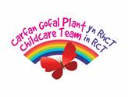

Childcare Provider Grant 2020 – 2021
Funded Places Template

